Lovable AI: Accelerating Full-Stack Development
Author: Raian Rahman

Introduction
Lovable (lovable.dev) is an autonomous AI software engineer designed to bridge the gap between high-level conceptualization and production-ready web applications. It is used to generate complete, functional full-stack projects using a modern tech stack consisting of React, TypeScript, Vite, and Tailwind CSS. This AI is particularly useful for rapid prototyping, building MVPs (Minimum Viable Products), and reducing the "boilerplate fatigue" that developers face during the initial stages of a project. By automating the scaffolding, styling, and basic state management, Lovable allows engineers to focus on high-level architecture and unique business logic rather than repetitive coding tasks.

Prompt
To demonstrate the capabilities of Lovable, the following detailed structural prompt was used to create a professional portfolio:

Input Prompt: "Build a stunning, modern 'Software Engineer Portfolio' website. Use React, Tailwind CSS, and Lucide React icons. It needs to be a single-page scrolling site.

Visual Aesthetic: Theme: Sleek, high-tech dark mode with frosted glass (glassmorphism) backgrounds and vibrant neon cyan and purple accents.
- Style: Premium, clean, with a strong focus on typography and spacing.

Layout & Features:
- Hero Section: A bold introduction ('Hi, I'm a Full-Stack Engineer'). Include a 'Download Resume' button with a glowing hover effect. Next to the text, add a mock 'Terminal' window that uses React state to simulate a typing effect (e.g., '> initializing portfolio... > system ready').
- Skills Grid: A grid of 6 cards showing different skills (e.g., React, TypeScript, Python, Node.js, AWS, UI/UX). When hovered, the cards should smoothly scale up and reveal a glowing border.
- Projects Section: 2 large project showcase cards. Each needs a dark placeholder image area, a project title, tech stack tags (like tiny pills), and a 'View Source' button.
- Contact Form: A clean form (Name, Email, Message) with a 'Send Message' button. When clicked, use React state to change the button to a green 'Message Sent!' state.

Constraints: Fully responsive (must look great on a mobile-sized preview).
- Add smooth fade-in animations as elements appear on the screen.
- Do not build a backend, just use React state to make the terminal and contact button interactive."

Output
The AI generated a fully functional single-page React application hosted at a temporary subdomain. The output consists of a responsive, high-fidelity user interface that adheres to the glassmorphism design language requested. Preview available here.

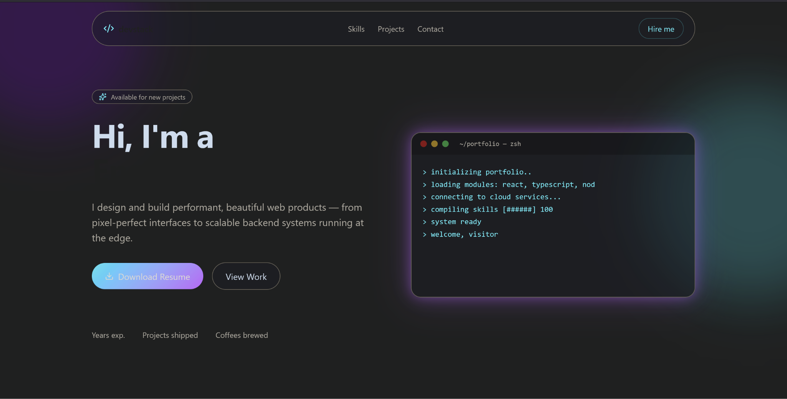

Description of output
The resulting application features a sophisticated dark-mode UI with a functional "Terminal" component in the hero section that types out initialization logs upon page load. The skills grid utilizes Tailwind’s transition utilities to provide smooth scaling effects, while the contact form successfully demonstrates client-side state management by updating the UI immediately upon "submission." Visually, the site maintains a premium aesthetic with consistent neon accents and balanced whitespace, effectively showcasing how AI can handle complex CSS layouts and React hooks simultaneously.

Prompt Engineering: Strategies for Refinement
Based on technical research into the Lovable platform, the following points are essential for refining prompts to achieve superior results:

- Atomic Component Definition: Rather than asking for a "page," define the UI in "atoms" (buttons, cards, modals, badges). Lovable interprets specific UI vocabulary much more accurately than general descriptions.
- Visual Aesthetic Keywords: Utilize "design tokens" in natural language. Words like "glassmorphism," "layered depth," "cinematic contrast," and "frosted surfaces" trigger specific Tailwind utility combinations that elevate the visual quality.
- The "Clarification" Hook: Always append the instruction: "Ask me any questions you need to fully understand the user journey before you start coding." This prevents the AI from making assumptions about logic or data flow.
- State-Specific Instructions: Explicitly mention React hooks. For example, "Use useState to toggle the visibility of the mobile menu" ensures the AI writes functional logic rather than just static CSS.
- Role-Based Prompting: Define the persona of the user (e.g., "Design this as an Admin Dashboard for a technical user who values data density over white space") to influence the information hierarchy.
- Constraint Guardrails: Use "Negative Prompting" to tell the AI what not to do, such as "Do not use external image URLs" or "Avoid using fixed pixel widths; use relative Tailwind units for responsiveness."

Conclusion
Lovable stands out in the current AI landscape as a "system-aware" builder. Compared to general-purpose tools like ChatGPT or Claude, which provide isolated code blocks, Lovable provides a managed environment that handles the entire developer lifecycle from scaffolding to deployment. While v0.dev is arguably better for generating individual, highly-polished UI components for existing projects, Lovable is superior for rapid end-to-end prototyping because it natively integrates with Supabase for back-end functionality. Bolt.new offers a similar experience, but Lovable’s "Visual Edit" feature—which allows users to click on the preview to make changes—makes it more accessible for design-heavy iterations. For a developer needing an MVP in hours rather than days, Lovable is currently the most robust "all-in-one" solution.

